Compiled by <

Corey Herington

Desmon Fields

Will Dimeo

Jagoba Marcos>

Last updated: August 04, 2014

**Ninjas VS Zombies: The Pizza Deliveries**

**Table of Contents**

Overview - Executive summary

High Concept:

Genre:

Comparable products:

Target Audience:

Key Features:

Goal:

Obstacles to the goal:

Overview - Interactivity

Controls:

Controller:

Keyboard and Mouse:

Arcade:

Cameras:

Overview – Game Modes

Game modes:

Overview - Art and Production Design

Style of Art and Animation:

Style of Audio Effects:

Style of Music:

Mechanics

Game Mechanics:

Win Condition

Loss Condition

Combat

Character creation

Leveling system

Turn system

Resources

Puzzles

Mini Games:

Content – Characters/Units

Playable characters:

Interactive non player characters:

Non interactive non playable characters:

AI controller characters:

Content – Items/objects

Consumable items

Equip-able items

Interactive items

Noninteractive items

Game Progress - World

Game Progress - Game events

Game progressions milestones:

Game screens – Interface Flow Chart

Game screens - Layouts

HUD

Front End Game Screens

In Game Screens

Technical Document

Asset Dependencies

Animations

Static images

Font image

Tiles

Script files

Particle effects

Sound effects

Background music

Pre-existing technology

File Formats

# Overview - Executive summary

## High Concept:

You’re Kintaro Pankiji a pizza delivery ninja that has to bring his order to Natas Za Akuma. This is based in a top down look at feudal japan with a demonic look to it. You have to do this while traversing the levels with your grappling hook.

## Genre:

The core is the puzzles and the stealth. However, there is a way to play the game as a beat’em up but that would be much harder.

## Comparable products:

Gameplay:

* Camera view

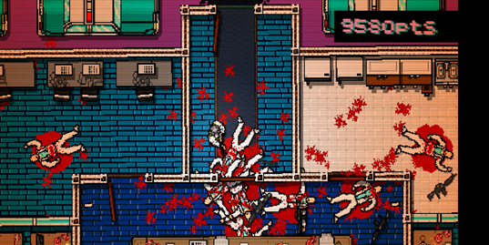

(Miami hotline) Our game will have top-down view

* the hook

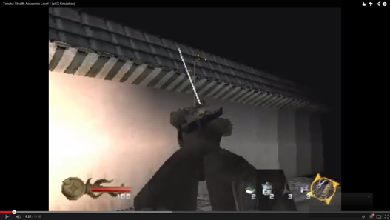

Like Tenchu game (image above) our game will have a grappling hook

* Game flow

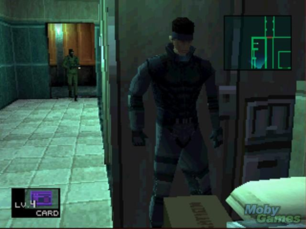

Like in Metal Gear Solid series (image is MGS from psx) our game will have many ways to beat the level: stealth way focusing on having a low profile or “Rambo” mode which means killing all enemies (or try to do it)

* Puzzles

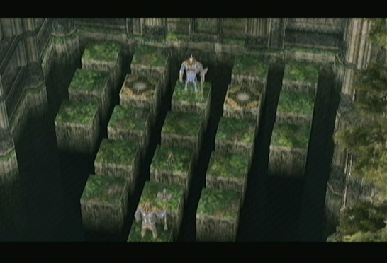

The Zelda series are very famous for their puzzles. Our game will also implement hard puzzles to challenge the player’s intelligence

* Maps

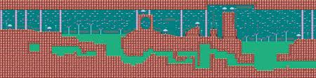

This image is from Sonic 2 (sega master system 2) in which shows a map with different paths. The game that we are going to develop will have various paths to complete the levels

Interface

* Timer

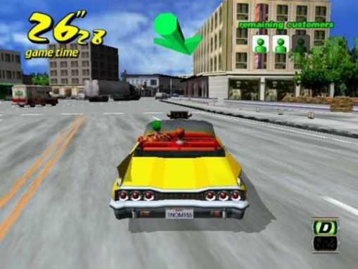

(Crazy Taxi) example of a timer

* Health bar

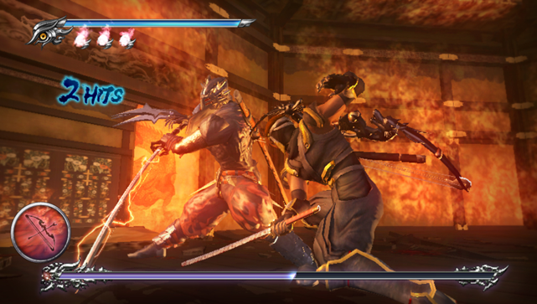

(Ninja Gaiden) health bar example

* Alert indicator

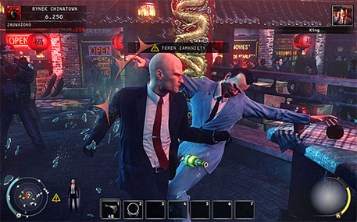

(Hitman Absolution) if you attack an enemy you will alert the nearby enemies and also start the alert protocol

Art style

* Characters

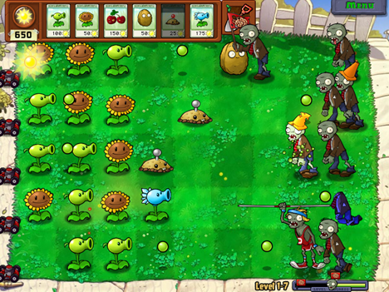

Plants vs Zombies, zombies design example

* Toppings and special items

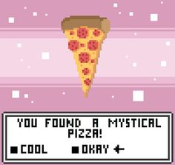

Message when player gets a topping or special item

* Boss

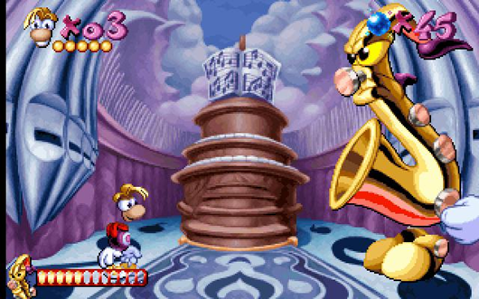

(Rayman). The boss level will be a separate room with a special hud and hot points which player will be able to interact with

## Target Audience:

Primary:

Middle school students and young adults, mainly males with large gaming experience. Basically, is oriented to hardcore gamers that enjoy hard challenges and mental quizzes.

Secondary:

Anyone who is interested in puzzle games with a new twist and unique story

## 

## Key Features:

-Time attack: the timer in the HUD is to increase the pressure on the player. Depending on how fast they do the delivery the money reward is better. However, if the time is up there isn’t a game over.

- Item usage: The constraint of using items only by dropping the pizza provides a mental challenge of critical thinking to solve the puzzles.

- Money system: To reward the actions and decisions like completing the level without raising the alert, solving all puzzles in the level, finding all the toppings in the level.

Goal:

Provisional Goals

* Different toppings in level upgrades(hidden).
* Get a tip for delivering in faster times
* Upgrading items/weapons/skills
* Completing all puzzles within floor
* Delivered on time streak bonus.
* Never lose your pizza
* Getting through the level
* Avoiding enemies
* Defeating all enemies
* Finding different traps and items
* Solving all the puzzles (in level)
* Finding all the toppings (in level)
* Watching all enemy types
* Completing the level without using consumable items

## Obstacles to the goal:

- Pizza: the main challenge is to protect the pizza from the enemies

- Puzzles: solving the puzzles to unlock doors or get rewards.

- Stealth: Evaluate what would be the best approach to get to the end.

- Money: More money means more upgrades

- Item usage: items can only be used dropping the pizza

- Enemy combination: Different type of enemies work better together to create new behavior and skills.

- Levers: this items can open locked doors or activate traps.

- Pitfalls: (in early prototype perma-death) to jump pitfalls the hook is the key

- Traps: there are many traps in each level, some are activated in the level start but there are others that are activated by triggers (step into a tile)

- Rooms/paths: Find and explore each room in the level

# Overview - Interactivity

## Controls:

### Controller:

Xbox controls

Left thumbstick = walk

Double tap and hold left-stick to run

A button = drop pizza/fight for pizza when in struggle

X button = use hook

Y button = use sword

B button = use item

Start button = pause

Select button = toggle show map

### Keyboard and Mouse:

WASD keys = walk

Double tap and hold WASD keys to run

Spacebar = drop pizza/fight for pizza when in struggle

J key = use hook

K key = use sword

L key = use item

Escape key = pause

M key = toggle show map

### Arcade:

joystick = walk

Double tap and hold joystick to run

0 button = drop pizza/fight for pizza when in struggle

3 button = use hook

4 button = use sword

5 button = use item

6 button = pause

1 button = toggle show map

## Cameras:

Top down view that switches rooms with the player like in the old zelda games.

# Overview – Game Modes

## Game modes:

Story mode - only mode. you will go through different levels by either by being stealthy or fighting your way through to reach the end of the level and deliver the pizza.

*If we have enough time:

* Hardcore mode: It is the story mode with the only difference of if the player sets the alarm is Game Over.
* Different difficulties in story mode: easy/medium/hard (enemy attributes)
* Vs mode: is like the story mode for 2 players. The goal is deliver the pizza before the other player.
* Zombie mode: user controls the zombies and has to get down the “hero”which is controlled by the CPU
* Survival mode: Story mode but the health doesn’t regenerate when player completes a level.
* Infinite tower mode: the goal of this mode is destroying all the enemies. Player can visit the shop at any time from the pause menu.

# Overview - Art and Production Design

## Style of Art and Animation:

Cartoonish: because of how its not realistic and can be more humorous

the legend of zelda series does a good job of this.

plants vs zombies is another good one.

## Style of Audio Effects:

cartoonish to add to the look like the zombies off of plants vs zombies

looney toons whoosh sound when falling

## Style of Music:

mix of old feudal asia music with newer electronic

# Mechanics

# Game Mechanics:

Tug-of-war - when you are attacked by a zombie while you have the pizza, you have to mash a button for a tug-of-war with that zombie. The zombie gets stronger for each zombie on his back.

Grappling hook - you have a grappling hook that you will use to solve almost every puzzle. It can be upgraded to increase it’s length and give it damage. You can pull your self to, pull to you, or make a distraction sound depending on what you hit with your hook.

Stealth - vision detection, enemies have a cone-shaped view that the player has to stay out of to not alert enemies. Sound detection, enemies are alerted if the player makes a loud enough sound that grabs the attention of nearby enemies.

Puzzles - there are going to be many different types that are described below.

### Win Condition

WIN

- Reach the end of the level with the pizza.

- Deliver the pizza in every level.

Loss Condition

LOSE

- Pizza is stolen.

- Lose all HP (Hit Points)

### Combat

Combat starts by one enemy spotting you and alerting all the other enemies in the room. If the player has the pizza and a zombie comes up to attack you, you go into a tug-of-war with him by mashing a button. Ranged ninjas will throw shurikens at you while you dodge them and work to get close enough to do your damage. Combat will end when all enemies are dead or you lose your pizza or all your health.

### Resources

DAQ(Don’t Ask Questions) coins - received after completing the level or breaking objects, it is based on the tip, the toppings, and any extra bonuses throughout the level. You can use them to upgrade weapons and stock up on items.

Toppings - can collect them throughout the level. They add bonus coins to the overall total amount you receive from completing the level.

### Puzzles

Lever puzzle:

Interact - Using hook/sword

Solving the puzzle

- Hitting the lever or switches with sword/hook

- Activating the levers in the correct order

Example:

The player must find the sequence to activate all the levers (4-3-5-2-1), this puzzle opens a locked door. The sequence will be shown throughout the level individually before the puzzle room.

# puzzle.png

Placement puzzle:

Interact - Using hook

Solving the puzzle

- Pull all objects into the correct spots or areas on the floor

Example:

The player must move all objects to the correct spots, this reveals a hidden door.

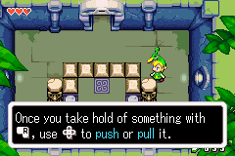

Environment Altering puzzle:

Interact - Using hook/sword

Solving the puzzle

- altering environment by changing a wall or object in the room

- breaking walls or hitting an object to activate a trigger for unlocking a door or path

Example:

The player must destroy a wall to unlock the hidden path to another room.

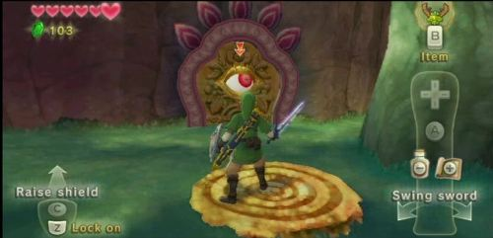

# 

# Content – Characters/Units

## Playable characters:

**Kintaro Pankiji:**

* Brief Description: young ninja in training
* Back-story: raised from an ancient and powerful family of ninjas that happen to own a pizza place.
* Visual Description: smaller ninja
* Visual Attributes: wears a black ninja garb with mask and has a Katana on his back with a grappling hook on his belt and pouch for smoke bombs
  + Gender:Male
  + Height:5’5”
  + Age:17
  + Hair color:Black
  + Hair style:spiky
  + Ethnicity/Skin tone:asian
  + Clothing:ninja
* Game Play Attributes
  + Hitpoints:base of 100 but can be upgraded by 20 per purchase
  + Attack power: (Strength*1.5) + Sword Damage
    - strength: base of 5 each upgrade adds 1 point max of 10
    - sword level: base damage of 5 adds 5 to damage every level max level of 5
  + Rate of attack:1.5-((strength *.1)+(Sword Level*.1))
  + Movement rate: base of 5 each upgrade adds 1 point max of 10
  + Cost: the base cost for an upgrade is 25 and adds 25 to the cost depending on the level of the attribute
* Abilities:

Grappling Hook: can use it to move to, move things to you, and pick up different objects

Katana: used to activate traps levers and kill enemies

Smoke Bomb: to help hide from enemies

* Game mechanics:

character doesn’t level up but the players attributes can be upgraded individually to work for how the player wants to play the game.

* Design influences:

<http://www.spriters-resource.com/pc_computer/spelunky/sheet/56425/>

* Vocabulary of motion
  + walk
  + run
  + die: Slow fall forward to his knees then on his face
  + attack: a quick sword slash from in front of the ninja
  + throw hook: swirls the hook beside him on the right side then throws it in front of him
  + throw smoke bomb: brings up his hand then brings it down to create a ball of smoke around him
* Effects necessary for character

attack needs animated and sound

walk/run needs animated maybe sound

die needs animated and sound

throw hook needs animated and sound

throw smoke bomb needs animated and sound

## Interactive non player characters:

**Ero-Senin:**

* Brief Description:older man who is kintaros grandfather has a beard and a fu manchu mustache.
* Back-story:he is the leader of the ninja clan and stays back to help upgrade and train his grandson
* Visual Description:
  + http://www.labeardcomp.com/wp-content/uploads/2012/06/al-leong-e1338570632478.png
* Visual Attributes
  + Gender:male
  + Height:5’0”
  + Age:Unknown
  + Hair color:white
  + Hair style:bald
  + Ethnicity/Skin tone: asian
  + Clothing:black robe
* Game Play Attributes
* Game mechanics:

he is the shop owner and who you talk to for when you want to upgrade your items or attributes

* Design influences:

<http://upload.wikimedia.org/wikipedia/hr/f/f3/Master_Roshi.jpg>

* Vocabulary of motion

he sits back and reads magazines while the player decides what he wants to buy

* Effects necessary for character

smoke for when he’s smoking a pipe

## AI controller characters:

**Zombie:**

* Brief Description: Undead enemy that attempts to steal the pizza from player.
* Back-story: Controlled by the ninja clan to help retrieve the pizza from kentaro.
* Visual Description: rotting body in normal attire
* Attributes:
  + Attack: 5
  + Attack speed: .7
  + movespeed: 3
  + attack range: 50 pixles
  + line of sight: 500
  + steal timer: 5 sec
* Effects necessary for character:
  + attack sound
  + move sound
  + death sound
  + alert sound
* Interactions

If the zombie runs into the player when they have the pizza, they enter a struggle for the pizza. When this happens the player has to repeatedly press a button to break away from the zombie stunning and giving the player a chance to move away.

* AI plan

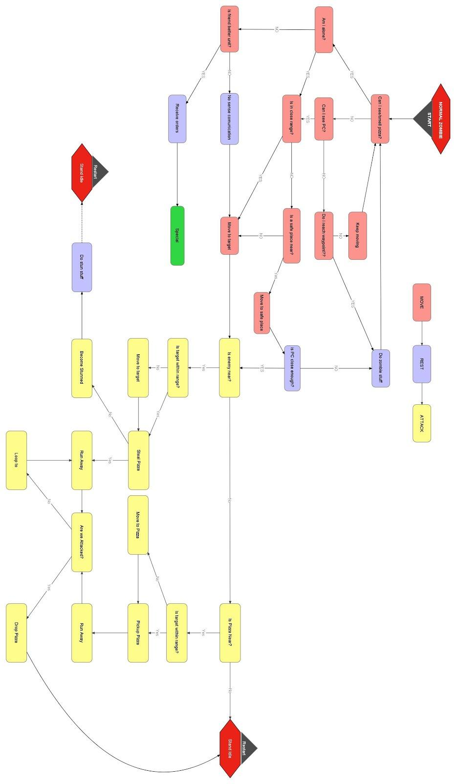

**Ranged Ninja:**

* Brief Description: Ninjas that throw shurikens from a distance when player is spotted.
* Back-story: Member of the ninja clan that the Natas Za Akuma hired to stop Kentaro from successfully delivering the pizza.
* Visual Description: a ninja that wont move and is on look out
* Effects necessary for character:
  + attack sound
  + move sound
  + death sound
  + alert sound
* Interactions

If the player is within the ninjas vision, the ninja will throw shurikens at him causing him to drop the pizza and knocking him back.

* AI plan

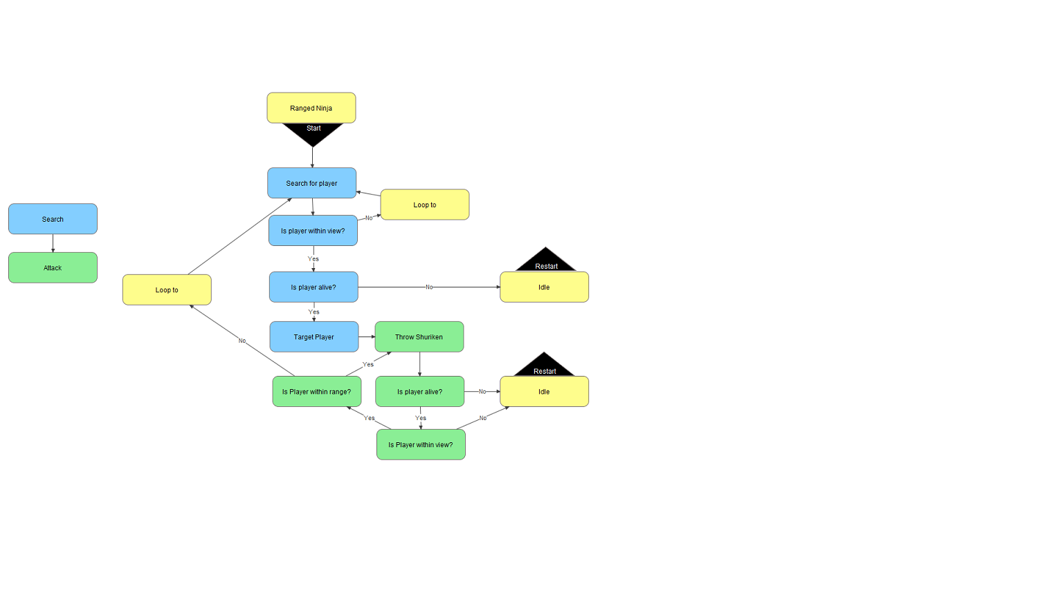

**<Ambush Ninja>:**

* Brief Description: Ninjas that hide from the player, until the player is far from the pizza.
* Back-story: Member of the ninja clan that the Natas Za Akuma hired to stop Kentaro from successfully delivering the pizza.
* Visual Description: a charging ninja
* Effects necessary for character:
  + attack sound
  + move sound
  + death sound
  + alert sound
* Interactions

If the player move far away from the pizza, the ninja will appear and attempt to steal the pizza, then run offscreen resulting in a failure to complete mission.

* AI plan

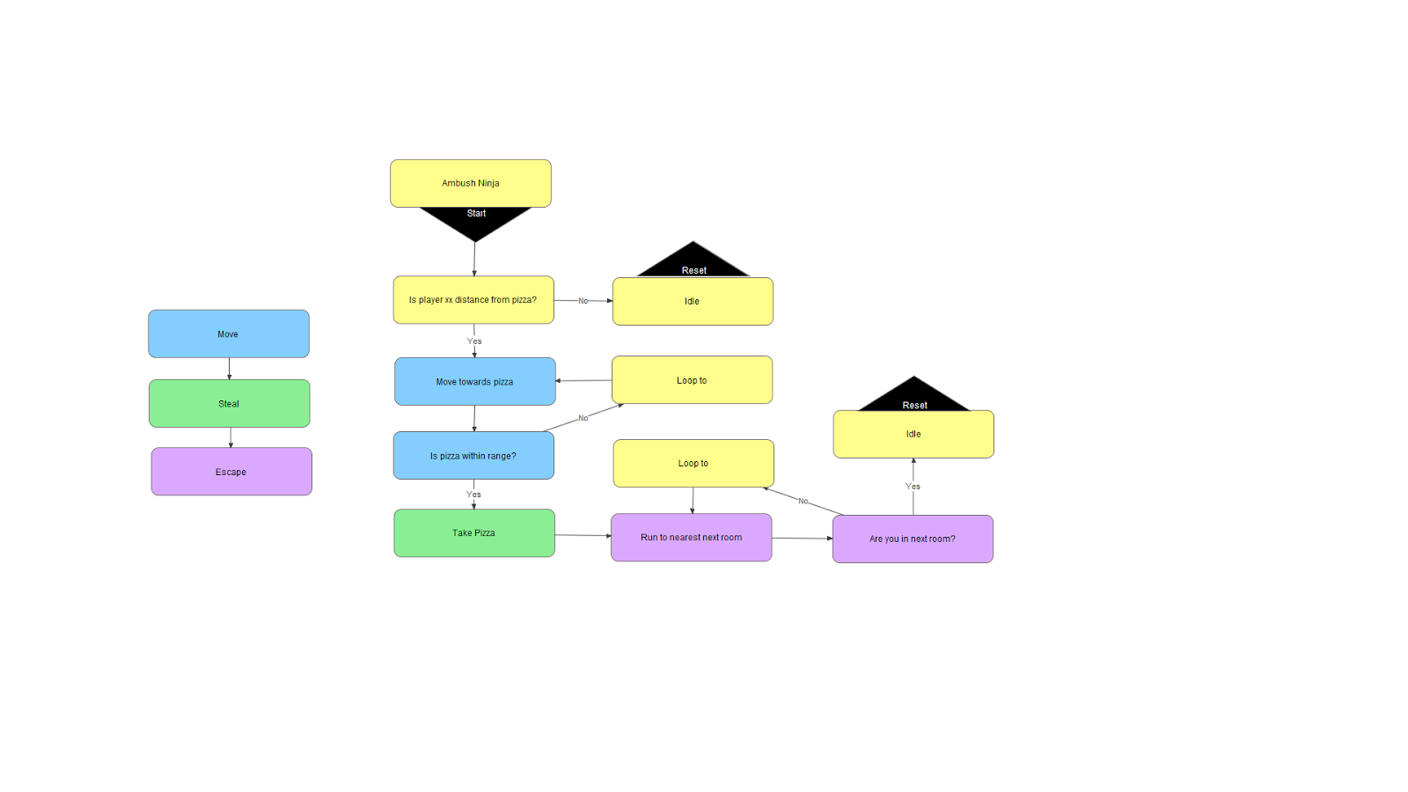

**Armored Zombie:**

* Brief Description: undead enemy that is covered in armor that cannot be destroyed.
* Back-story: Controlled by the ninja clan to help retrieve the pizza from kentaro.
* Visual Description: a darker tinted zombie
* Effects necessary for character
  + attack sound
  + move sound
  + death sound
  + alert sound
* Interactions

If the player tries to hook the zombie, he will grab the hook and pull the player toward him. The player’s sword will not damage the zombie. He also just like the regular zombie tries to steal pizza from you in a struggle.

* AI plan

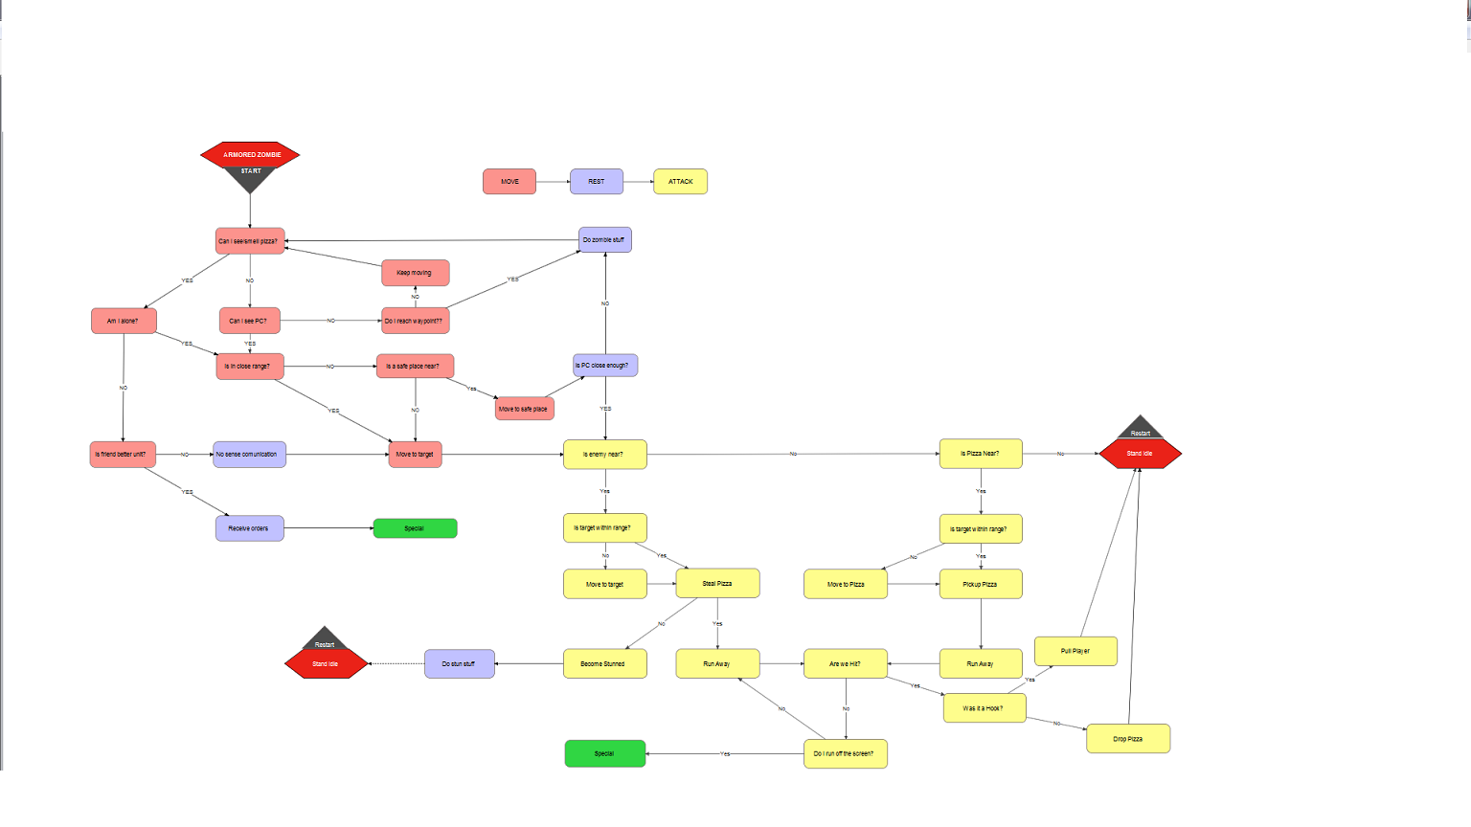

**<Boss 1 - King Pin”Gluttony & Greed”>:**

* Brief Description: Fat greedy man who wants your pizza, and wants to obtain it by any means
* Back-story: One of Natas Za Akuma’s trusted guardians
* Visual Description: king pin
* Effects necessary for character:
  + attack sound
  + move sound
  + death sound
  + alert sound
  + attack animation
  + move animation
  + death animation
* Interactions: when he hits the player for the first time he takes all his money. when he gets hit he bounces back a bit. when he is eating the pizza, he only focus on it and doesn't care for the player.
* AI plan

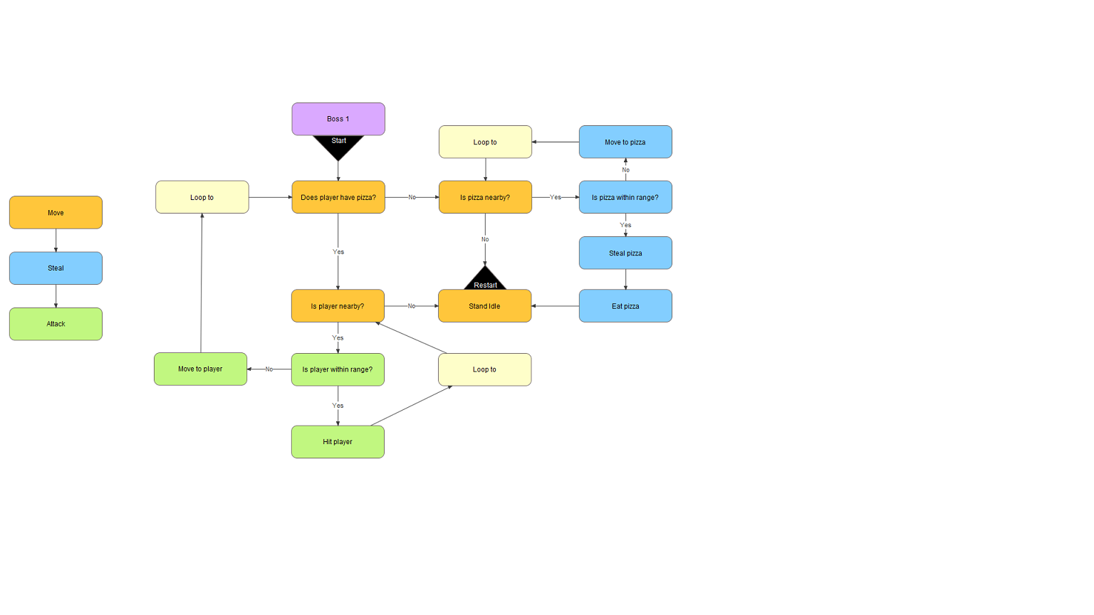

**Boss 2 - Lady Lucille “Lust & Wrath”:**

* Brief Description: Flirty lady that gets angry when you do not fall for her charm.
* Back-story: One of Natas Za Akuma’s trusted guardians
* Visual Description: a dominatrix with a whip
* Effects necessary for character:
  + attack sound
  + move sound
  + death sound
  + alert sound
  + attack animation
  + move animation
  + death animation
* Interactions: she will try to charm you into a trap, if she fails to charm you she will get mad and charge at you. if she hits you, you take great damage. if she misses she takes damage
* AI plan

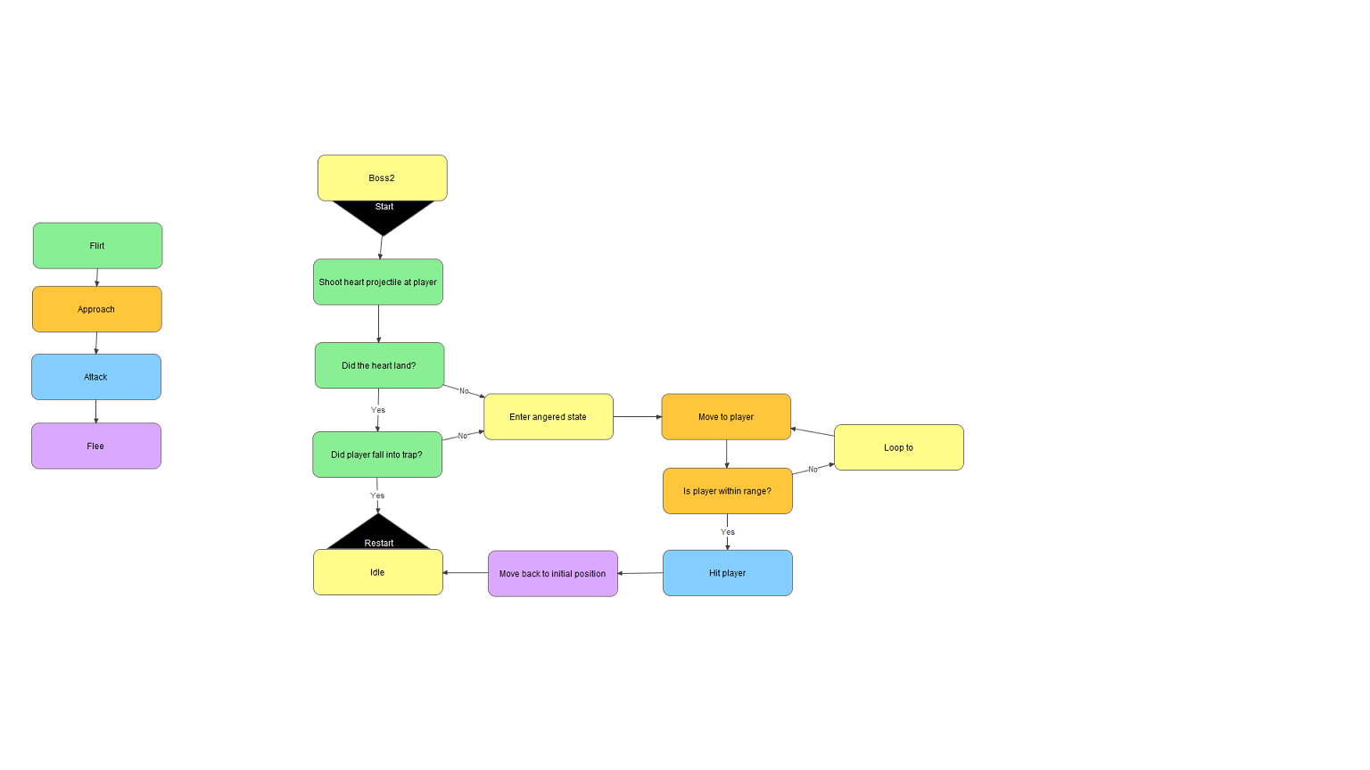

**Boss 3 - Zarrak “Envy & Sloth“:**

* Brief Description: Envious boy that wants to be a ninja, just like kentaro.
* Back-story: One of Natas Za Akuma’s trusted guardians
* Visual Description: a darker version of the player, a shadow of him.
* Effects necessary for character:
  + attack sound
  + move sound
  + death sound
  + alert sound
  + attack animation
  + move animation
  + death animation
* Interactions: the first time he will only mirror your moves. once hit he will start to fight back, once hit again he will be stronger and attack faster
* AI plan

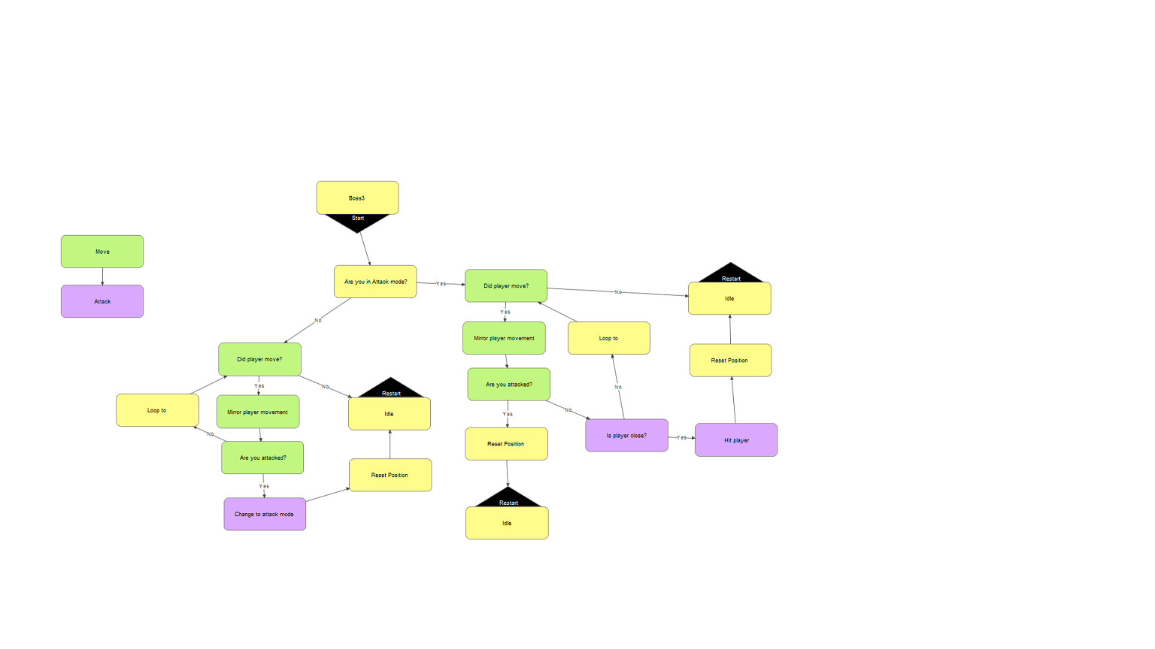

**Boss 4 - Puraido ”Pride”:**

* Brief Description: Cocky brute who loves to toy with and torture his opponents.
* Back-story: The most trusted guardian and right-hand man of Natas Za Akuma
* Visual Description: a rogue samurai
* Effects necessary for character:
  + attack sound
  + move sound
  + death sound
  + alert sound
  + attack animation
  + move animation
  + death animation
* Interactions: hit with the player’s sword, will taunt the player. only takes damage from the traps in the room. once the player brought the boss into each trap, thats when he can finish him with the sword.
* AI plan

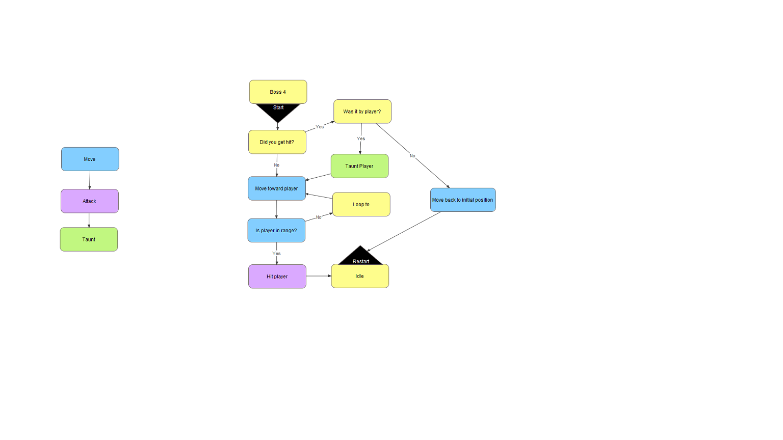

# 

# Content – Items/objects

**Consumable items**

**Smoke Bomb:**

* Brief Description:small ball that can be thrown to make an area of smoke
* Visual Description:small ball
* Design influences:

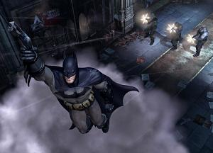

Batman series: Dark gray smoke cloud

* Game Play Attributes
  + it doesn’t allow anyone within it to be seen
  + Stats:

- Duration = 5 secs

- Area = 128 pixels around the player

* Effects necessary for item

## Equipable items

**Grappling Hook:**

* Brief Description:a Grappling hook used to help game progression
* Visual Description: a grappling hook with a rope attached
* Design influences: Tenchu picture is up above
* Game Play Attributes
  + Hitpoints gained/lost: 0
  + Attack power buff/debuff: 0
  + Rate of attack buff/debuff: 0
  + Defense rating buff/debuff: 0
  + Movement rate buff/debuff: 0 but can move you to an area
  + Weight: 0
  + …
* Effects necessary for item
  + Collides with wood -> sound and particle effect
  + collides with metal
  + collides with rock
  + (when collides with any surface)

knocks an enemy back, when fully upgraded it will stun the enemy.

a sound for when it hits metal, wood, flesh, pizza. a sound for when it is used. if it hits metal it makes sparks, if it hits wood it makes parts of the wood. animation for when its used.

**Sword:**

* Brief Description: a katana used to vanquish foes
* Visual Description: basic katana that can gain new color
* Design influences: Ninja Gaiden
* Game Play Attributes
  + Hitpoints gained/lost:0
  + Attack power buff/debuff:5 + 5 per level max 30
  + Rate of attack buff/debuff: 0
  + Defense rating buff/debuff:0
  + Mana regen rate buff/debuff:0
  + Movement rate buff/debuff: 0
  + Weight:
  + …
* Effects necessary for item

slashing sound when used, sparks if hits metal or rock, splinters flying if hits wood, blood for when it hits flesh.

## Interactive items

**Potted plants:**

* Brief Description: small breakable object that when broken has a chance for health or money.
* Visual Description: a small potted plant
* 
* Design influences: darksiders
* Interactions: they can break it with their sword or hook
* Effects necessary for item

small particle effect of the pot breaking, and a sound of it breaking

**Wooden boxes:**

* Brief Description: small movable object with your hook
* Visual Description: a small wooden box
* 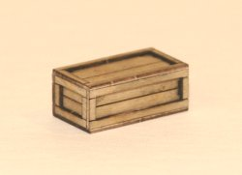
* Design influences: zelda
* Interactions: they can move it with their hook
* Effects necessary for item

sound of the hook hitting it.

**Metal boxes:**

* Brief Description: small or big metal boxes that can’t be moved
* Visual Description: big or small metal box
* 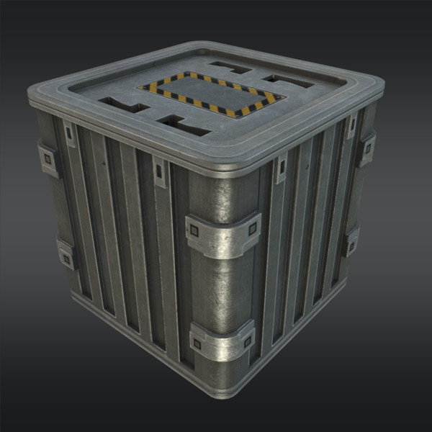
* Design influences: zelda
* Interactions: they can move to it with their hook
* Effects necessary for item

sound for hitting it and when the player runs into it

**Metal walls:**

* Brief Description:walls that prevent the player from cheating
* Visual Description: top-down view can’t really see the wall
* Design influences: metal gear solid
* Interactions: they can hit it with their hook or sword
* Effects necessary for item

sound for hitting it and when the player runs into it

# 

# Game Progress - World

**Tutorial Level [Level 1 (Gluttony & Greed)]:**

Brief Description:

The setting is messy; big piles of food and gold. If the player walks on gold makes more noise. In this level player learns the different dynamics doing each action, to do so the player will have small messages displayed on the screen. This level should take 5 - 7 minutes. In the level end there is the first boss: Gluttony and Greed.

Visual Design:

night time clear sky inside an old building.

Back Story:

our family motto is that “ we can and will deliver to anywhere and anyone no questions asked!” we are delivering a pizza to Natas Za Akuma and he is doing everything in his power to try to get the pizza for free.

Key Locations:

in your map there will be pinpoints that are “hot spots” for you to check out. to help with your pathfinding

Rules:

you can’t walk through walls, boxes, ect..

Behaviors:

there are movable boxes that you can move and other boxes that you can’t to show you how your hook works.

show how sword works

show how to move small objects

show how to move onto big objects

show how traps work

show how to solve puzzles

show how levers work

beat first boss

Environmental Aspects:

The doors will be unlocked after completing the tutorial action:

Room 1(Pizza):

Player must grab the pizza and drop it twice. Doing so will unlock the door

Room 2 (hook):

Player must take the hook and use it twice.

Room 3(sword):

player must take the sword and make two swings.

Room 4 (levers):

A short text will be displayed on the screen with brief explanation of how levers work. there are two levers-> one must be activated using the hook, the other with the sword. This will open the Upper side door.

Room 5 (traps):

This room will show the trap triggers and deal some damage to the player. There is a unlimited health source to heal the player. Player must activate the lever after that if player took damage and healed then the player can leave the room.

Room 6 (Small boxes):

In this room player must move small boxes to certain locations to open the next door. There are also breakable objects that drop money and power ups.

Room 7 (Big boxes):

this rooms haas pitfalls and the goal is jumping them using the hook. This door is unlocked

Room 8 (puzzle 1):

this room don’t have much elements. It explains how to solve the puzzles. In this case is lever sequence puzzle. The tutorial shows a smal object that can be accessed by suing either sword or hook. In it is the sequence to solve the puzzle.

This opens room 9 (message of “it seems like something has been unlocked)

Room 9 (puzzle 2):

This puzzle don’t have any help, the player must solve it by itself.

Room 10 (boss):

Use the sword to beat it.

Initial world layout:

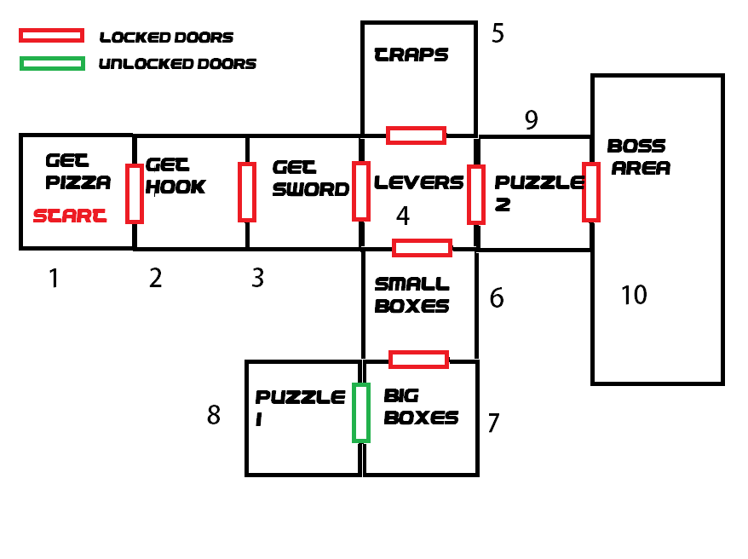

**Level 2 (Lust & Wrath):**

Brief Description:

Takes you through a set of trials that is based on the theme of lust and wrath. Its a medium sized level, that should take 7 to 10 min of playtime.

Visual Design:

night time cloudy sky inside an old building.

Back Story:

This is floor of the psychotic lady lucille, who flirts with anyone that comes into her dungeon, you better not hurt her, “for hell has no fury like a woman scorn”. She is a tall female with black hair, who wears a purple kimono and has her hair tied in a ponytail.

Key Locations:

There are three key areas of this level, the two puzzle rooms, and the danger area.

Rules:

Every room either is based on lust or wrath. If it is lust the room tries to keep you from moving forward. If it is wrath, the room is partially filled with hidden traps. Getting past a room turns the room into a neutral room, which makes it safe to pass through.

Behaviors:

More enemies spawn as you get farther from the boss room.

none

Environmental Aspects:

none

Initial world layout:

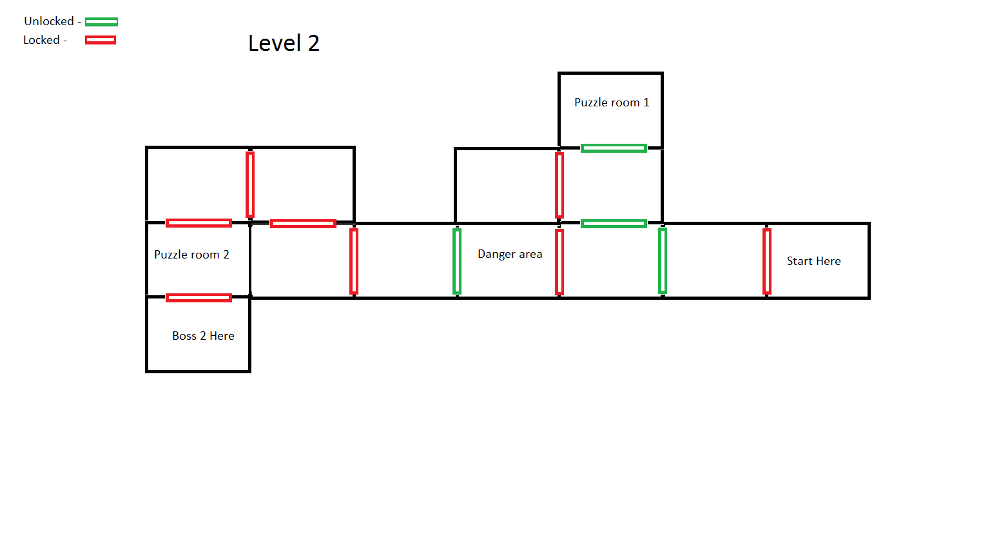

**Level 3(Envy&Sloth):**

Brief Description:

This will be a weird dream world where the colors are different. the player will wake up in this world wondering what happened and why he’s here.

Visual Design:

can’t tell what time or anything because it’s all in a dream.

Back Story:

You are in the mind of the creature known as Zarrack. this creature is almost always sleeping and if not he is trying to be just like the others he sees or better than them.

Key Locations:

There are three key areas of this level, the different boss rooms they change when Zarrack takes damage and wants to try to change the layout to get away.

Rules:

Zarrack is a dark image of the player and mirrors his movements and actions to try and be the player.

Behaviors:

there are only a few enemies at the start.

the character is teleported to a different boss room each time Zarrack is hit till room 3.

Environmental Aspects:

none

Initial world layout:

# 

# final lvl

Brief Description:

this is the final level, this level will be taking everything you know and putting it all together.

Visual Design:

you're deep in a castle with few windows, the sun is setting and its getting late.

Back Story:

you are getting fed up with all these strange deliveries and getting tired of it really fast. little do you know is that this is the last one. and here you will face Puraido

who doesn't care what you do, he will do whatever he can to stop you from delivering the pizza at all costs.

Key Locations:

there are a few rooms you won't be able to go till you hit the switch that could be rooms away from that door. and the last room you enter you fall through the floor and you will be dropped in the boss room stuck with no way out.

Rules:

Puraido is will laugh at your attempts to hit him with your sword till you get him stuck in the 4 traps.

Behaviors:

there are meny enemys and a lot of pit falls. there are also a lot of puzzles that you have to go through in order to find the last order of the switches.

Environmental Aspects:

none

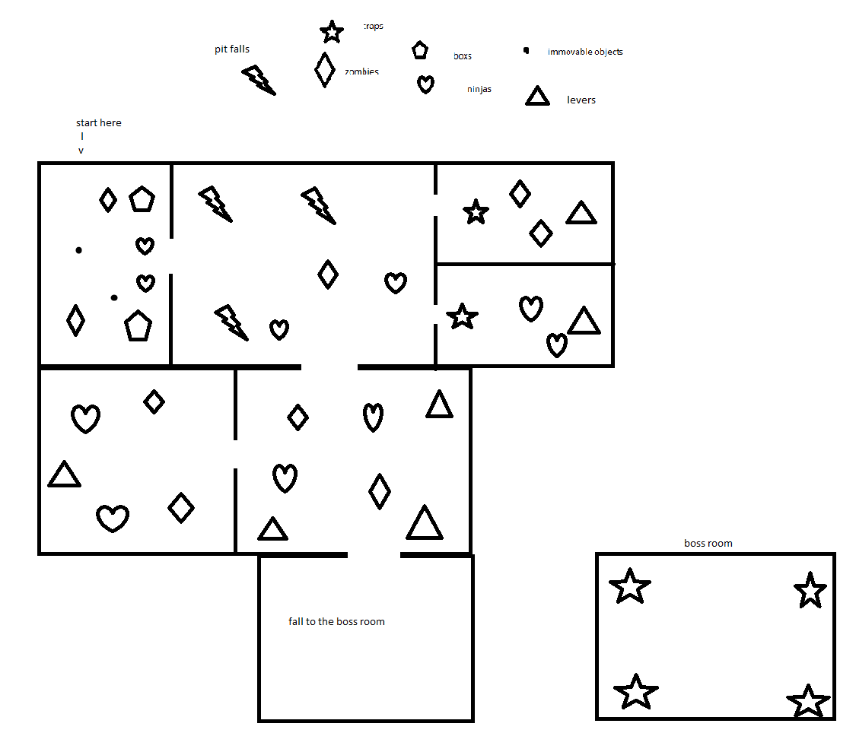

# 

# Game Progress - Game events

## Game progressions milestones:

* your told you have to deliver a pizza and to do it in a hurry
* you start off in a building where you are told you have to make it to the end for the delivery
* you travel through the rooms and solve the first puzzle to get further
* while dodging zombies and other ninjas you find another puzzle needing to be solved
* after solving this one you find yourself at room with a giant man
* you fight him to keep him from taking the pizza and after your success you deliver the pizza to natas za akuma
* then you go back home to check out and upgrade your gear
* you do not have to upgrade right after each stage, but it would make it harder to complete levels

# Game screens – Interface Flow Chart

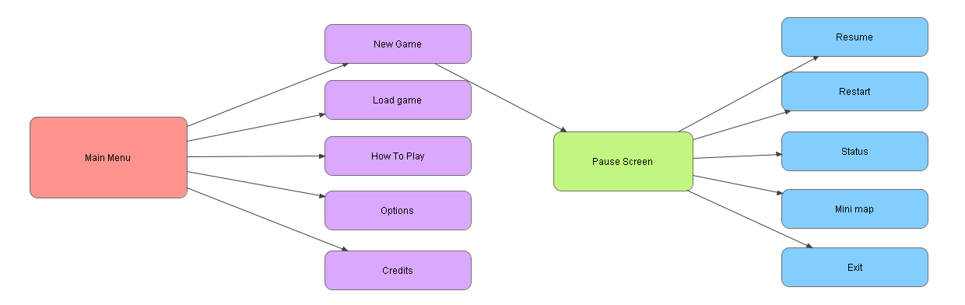

Main menu:

- Up/down to change selection

- button 1 to accept

- Button 2 to go back

In game:

- Player 1 to pause the game

- Up/down to change selection

- button 1 to accept

# 

# 

# Game screens - Layouts

Main:

1. Game image
2. Selections
   1. New game -> starts new game giving the player to player to select the slot
   2. Load game -> Opens slot screen to select the desired game
   3. How to play -> small slideshow with all game dynamics
   4. Options -> Basic game settings
      1. Sound volume
      2. Effects volume
      3. Brightness
   5. Credits-> small animation with all the people who contributed in the game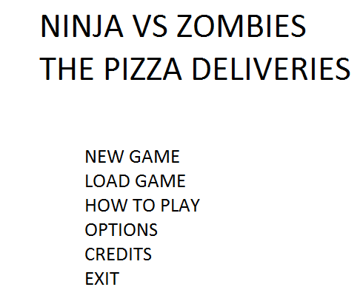

## 

## HUD

<Image of an example layout>

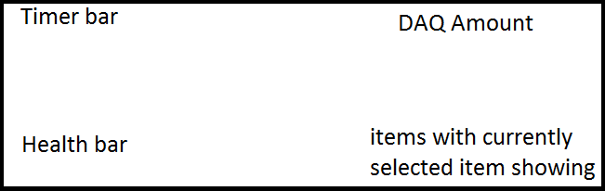

it shows the time left for a tip, your health, how much money you have, and your items

when he is hit there is a sound, when the pizza is getting stolen it makes a sound and screen flashes red

## Front End Game Screens

(out of game)

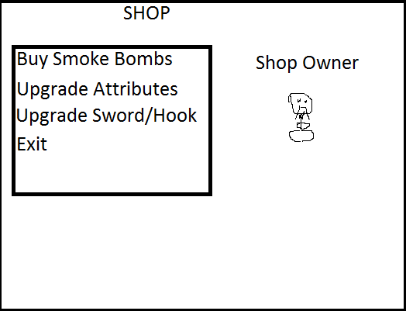

**SHOP**

Here you will be able to spend the money you earn throughout the game to upgrade your weapons, your stats, or buy more smoke bombs to use.

A cash register sound whenever you buy something, a sensei in the background of the shop who is reading a magazine. He’s meant to be there as a face for the person you’re talking to at the shop.

## In Game Screens

(Conversation menus, in game pop ups, game play menus)

fighting progression bar for the pizza

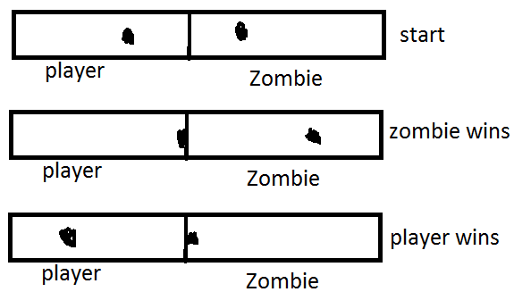

# Technical Document

# Asset Dependencies

## Animations

**<Kentaro Pankiji>:**

Description:the main character of the game needs to attack with his sword and throw his hook along with the basic movements.

Animations needed:sword slashing

running

hook throwing

throw smoke bomb

dropping the pizza

falling

getting hit

Average size of frames (in pixels):32x32

Similar examples:

<http://www.spriters-resource.com/pc_computer/spelunky/sheet/56425/>

**<King Pin, Gluttony/Greed>:**

Description:Big fat guy in a suit that walks around

Animations needed:

walking

running

falling

getting hit

Average size of frames (in pixels):64x64

Similar examples:

<http://www.lunchbreakcomics.com/kingpin.jpg>

**<Zarrak, Sloth/Envy>:**

Description:Dark image of the main character

Animations needed:sword slashing

running

hook throwing

throw smoke bomb

dropping the pizza

falling

getting hit

Average size of frames (in pixels):32x32

Similar examples:

<http://www.spriters-resource.com/pc_computer/spelunky/sheet/56425/>

**<Lady Lucille, lust/wrath>:**

Description: tall charming lady that has a whip to hit her enemies

Animations needed:

walking

running

falling

getting hit

whipping

Average size of frames (in pixels):64x32

Similar examples:

<http://fc02.deviantart.net/fs71/f/2012/328/d/c/whip_kof_um_by_orochidarkkyo-d5m09lv.png>

**<Puraido, Pride>:**

Description: Robed samurai

Animations needed:

walking

running

falling

getting hit

slashing

taunting

Average size of frames (in pixels):32x32

Similar examples:

<http://th08.deviantart.net/fs17/300W/f/2007/216/8/4/samurai_Kojima_Yose_by_DXSinfinite.jpg>

## Static images

**<Static object>:**

Description:

Average size (in pixels):

Similar examples:

**<Small Wooden Box>:**

Description:a small wooden box for the player to move around

Average size (in pixels):16x16

Similar examples:<http://www.clker.com/cliparts/3/R/N/S/B/a/wood-box-md.png>

**<Metal Box>:**

Description:a small Metal box that the player pulls himself to

Average size (in pixels): 16x16

Similar examples:



**Potted plants:**

Description: small breakable object that when broken has a chance for health or money.

Average size (in pixels): 16x16



## Font image

**<Asian letters>:**

Description: cartoonish asian

Average size (in pixels): 16

Similar examples:

<http://www.google.com/imgres?imgurl=http%3A%2F%2F3.bp.blogspot.com%2F-jO_EommpuPM%2FUrXLHajOM7I%2FAAAAAAAADRE%2Fa41hyXHWT_4%2Fs1600%2FAsian-alph.jpg&imgrefurl=http%3A%2F%2Fcreativeupcycling.blogspot.com%2F2014%2F01%2Fmaking-my-own-alphabet-stamps.html&h=419&w=1000&tbnid=YqxeUaE3MXitsM%3A&zoom=1&docid=8AvMz5YCixUg0M&ei=hhzpU6rYA-rMsQTx4YC4DQ&tbm=isch&ved=0CB4QMygAMAA&iact=rc&uact=3&dur=751&page=1&start=0&ndsp=36>

## 

## 

## Tiles

**<Tile set Name>:**

Description: tower floors.

Tiles needed in set: 10

Average size (in pixels):

Similar examples:

<http://fc05.deviantart.net/fs70/f/2013/066/d/d/indoor_free_tileset__by_thegreatblaid-d5x95zt.png>

## Script files

**<Scrip Name>:**

Description:

Similar examples:

Particle effects

**<Sparks>:**

Effect description: bright small flares

Particle Images needed:

Average size (in pixels): 1

Similar examples:

<http://effextures.com/wp-content/uploads/2013/08/Effextures-BurnMarks26.jpg>

**<Wood Chips>:**

Effect description: dark wooden rhombus

Particle Images needed:

Average size (in pixels): 3

Similar examples:

<http://sequoiascape.com/wp-content/uploads/2012/05/Black-Chips.jpg>

**<Fire>:**

Effect description: bright red that fades into yellow

Particle Images needed:

Average size (in pixels): 3

Similar examples:

<http://jackidelecki.com/wp-content/uploads/2013/09/FIRE-2-GENERIC.jpg>

**<Electricity>:**

Effect description: bright zigzagged lines

Particle Images needed:

Average size (in pixels):5

Similar examples:

<http://3.bp.blogspot.com/-ClOaNjbUPg8/TxBearSJARI/AAAAAAAAAbs/OwFK67EamHY/s1600/electricity.jpg>

## Sound effects

**<Sword Slash>:**

Description:sword slash for when the player swings his sword

Similar examples:

<http://soundbible.com/706-Swoosh-3.html>

**<Hook throw>:**

Description: a whooshing sound for when the hook is thrown

Similar examples:

<http://www.pond5.com/sound-effect/24235363/droid-grappling-hook-shot.html>

**<Grunt>:**

Description: young male grunt for when the player is hit

Similar examples:

<http://www.audiomicro.com/tracks/dialog/940374>

**<Zombie Grunt>:**

Description: raspy grunt from zombie when it's attacked

Similar examples:

<http://soundbible.com/1040-Zombie-Gets-Attacked.html>

**<Metal Thud>:**

Description: for when a metal object is hit by the hook or sword

Similar examples:

<http://www.sounddogs.com/sound-effects/101/mp3/130469_SOUNDDOGS__me.mp3>

**<Wooden Thud>:**

Description: for when a wooden object is hit by the hook or sword

Similar examples:

<http://www.sounddogs.com/sound-effects/2110/mp3/137989_SOUNDDOGS__bo.mp3>

**<scream>:**

Description: for when the player falls he screams till he restarts

Similar examples:

<http://www.sounddogs.com/sound-effects/2226/mp3/508508_SOUNDDOGS__ma.mp3>

**<ninja alert sound>:**

Description: the sound the zombies or ninjas make when they see the player

Similar examples:

<http://www.sounddogs.com/previews/2226/mp3/508025_SOUNDDOGS__ma.mp3>

**<zombie alert sound>:**

Description: the sound the zombies or ninjas make when they see the player

Similar examples:

<http://www.sounddogs.com/previews/2226/mp3/508026_SOUNDDOGS__ma.mp3>

## Background music

Similar examples:all from westar music website

**<Crest the Himalayas>:**

Description: Asian electronic with an old style feel for main menu

Similar examples:

**<Strings of Siberia>:**

Description: Asian style with electronic/ old style for upgrade menu

Similar examples:

**<Ancestors Path>:**

Description: Asian style with electronic/ old style for level 1

Similar examples:

**<Break Away From The Pack>:**

Description: electronic mystical

Similar examples:

**<Break Loose>:**

Description: Fast paced rock for boss battle

Similar examples:

**<Dangerous Steps>:**

Description:fast paced short burst for win

Similar examples:

**<Delirium>:**

Description: Fast paced electronic for boss battle

Similar examples:

**<Espionage and Deception>:**

Description: Mystical and slow oriental style for level 2 song

Similar examples:

**<Flight to Freedom>:**

Description: Mystical for level song

Similar examples:

**<Follow Me Down>:**

Description: Rock for boss battle

Similar examples:

**<Going the Mile>:**

Description:Electronic for level

Similar examples:

**<Ninja Master>:**

Description: oriental feel slow paced and mystical for level

Similar examples:

**<Pivot Point>:**

Description: Rock with inspirational feel for final boss

Similar examples:

**<Through the Ages>:**

Description: Slow and mystical for game over

Similar examples:

# Pre-existing technology

**<SGD Entity Manager>:**

Use:Entity Manager

Current functionality: handles entities and deletes them using reference counting

Changes Necessary:

**<SGD Wrappers>:**

Use:Message system

Current functionality: handles messages sent by invoking objects to carry out an action

Changes Necessary:

**<SGD Wrappers>:**

Use:event system

Current functionality: notifies all objects, and whichever object listens for that event handles an action

Changes Necessary:

**<SGD Wrappers>:**

Use:audio manager

Current functionality: plays,loads,and loops sounds and music files

Changes Necessary:

**<SGD Wrappers>:**

Use:Graphics manager

Current functionality: renders, loads and alters images

Changes Necessary:

**<SGD Wrappers>:**

Use:Input manager

Current functionality: allows for controller and keyboard input

Changes Necessary:

**<SGD Wrappers>:**

Use:Handle Manager

Current functionality: allows maintaining and using handles

Changes Necessary:

**<SGD Wrappers>:**

Use: Handle.h

Current functionality: allows making of handles of graphics audio and voice

Changes Necessary:

**<SGD Wrappers>:**

Use: Geometry.h

Current functionality: Allows for use of Rectangle vector point

Changes Necessary:

**<SGD Wrappers>:**

Use: Event.h

Current functionality: allows making of events

Changes Necessary:

**<SGD Wrappers>:**

Use: Listener.h

Current functionality: allows setting up who acts on which event

Changes Necessary:

**<SGD Wrappers>:**

Use: Color.h

Current functionality: allows of colors

Changes Necessary:

**<SGD Wrappers>:**

Use: Key.h

Current functionality: allows access to key enum

Changes Necessary:

**<SGD anchor animation >:**

Use: Anchor Animation

Current functionality: Animate sprite sheet using anchor point

Changes Necessary: animation manager, add parameter to handle xml read to manage different animations.

**<SGD Bitmap font>:**

Use: BitmapFont

Current writes text using bitmap font image

Changes Necessary: edit parameters to manage padding, different width and height, add parameter to handle xml read to manage different bitmap fonts.

**<STD Map>:**

Use: Map.cpp

Current structure composed by key and a value to manage objects

Changes Necessary:

<Tiny XML>

use: Tiny Xml

Current functionality: create a file that can be saved and loaded

File Formats

**World file:**

<?xml version="1.0" encoding="utf-8"?>

<Sheet version=""></Sheet>

<FileName></FileName>

<Levels>

<Level Name=”” NumberOfRooms=”” Boss=”” Tileset=””></Level>

<Tiles>

<Tile id=”” posx=”” posy=”” width=”” height=””></Tile>

</Tiles>

<Rooms>

<Room ID=””>

<SpawnPoints>

<Point posx=”” posy=”” object=”” rate=”” count=””></Point>

</SpawnPoints>

<WayPoints>

<Point posx=”” posy=”” object=””>

<Neighbors>

<Point posx=”” posy=””></Point>

</Neighbors>

</Point>

</WayPoints>

</Room>

</Rooms>

</Level>

</Levels>

</Sheet>

**Animation File:**

<?xml version="1.0" encoding="utf-8"?>

<Sheet version=""></Sheet>

<FileName></FileName>

<Animations>

<Animation Name="" IsLooping="">

<Frames>

<Frame FrameNumber=""AnchorPointX=""AnchorPointY=""Time=""Trigger="">

<RenderRect x="" y="" height="" width=""/>

<ActiveCollisionRect x="" y="" height="" width=""/>

<PassiveCollisionRect x="" y="" height="" width=""/>

</Frame>

</Frames>

</Animation>

</Animations>

**Particle file:**

<?xml version="1.0" encoding="utf-8"?>

<Sheet version=""></Sheet>

<Asset Type="FireParticle.ParticleSettings">

<FileName> SGD:String </FileName>

<Position> Point </Position>

<Spread> float </Spread>

<Size>SGD:Size </Size>

<Width> int </Width>

<Height>int </Height>

<PositionX> int </PositionX>

<PositionY> int </PositionY>

<MaxParticles> int </MaxParticles>

<SpawnRate> float </SpawnRate>

<Flyweight>

<MinLife> float </MinLife>

<MaxLife> float </MaxLife>

<ColorStartA>float </ColorStartA>

<ColorStartR>float </ColorStartR>

<ColorStartG>-float </ColorStartG>

<ColorStartB>float </ColorStartB>

<ColorChangePerSecA> float </ColorChangePerSecA>

<ColorChangePerSecR> float </ColorChangePerSecR>

<ColorChangePerSecG>float</ColorChangePerSecG>

<ColorChangePerSecB>float</ColorChangePerSecB>

<ScaleStart>float </ScaleStart>

<ScaleChangePerSec>float </ScaleChangePerSec>

<RotationStart>float </RotationStart>

<RotationChangePerSec>float </RotationChangePerSec>

<VelocityStart>float </VelocityStart>

<VelocityChangePerSec>float </VelocityChangePerSec>

</Flyweight>

</Asset>

**Game settings:**

<?xml version="1.0" encoding="utf-8"?>

<Sheet version=""></Sheet>

<FileName></FileName>

<Settings>

<Music volume=””></Music>

<Sfx volume=””></Sfx>

</Settings>

**Game progress:**

<?xml version="1.0" encoding="utf-8"?>

<Sheet version=""></Sheet>

<SaveFile>

<Slot> </Slot>

<LevelPlaying> </LevelPlaying>

<Toppings>

<LevelID> </LevelID>

</Toppings>

<HookLevel> </HookLevel>

<SwordLevel> </SwordLevel>

<Strength> </<Strength>

<Stealth> </Stealth>

<MaxHealth> </MaxHealth>

<MoveSpeed> </MoveSpeed>

</SaveFile>